

**Introduction:**

This report presents a comprehensive analysis of sales and profit trends using the Sales and Profit Analysis Dashboard.

The purpose of this dashboard is to provide a clear and insightful overview of the company's sales performance, profit margins, and regional analysis to support data-driven decision-making. The dashboard includes various visualizations that highlight key aspects of sales and profitability over time.

**Methodology:**



The analysis is based on the sales data of 2015, which includes detailed information on order dates, regions, customer segments, and product categories.

The data was processed and visualized using Tableau. Calculated fields such as profit margins and return rates were created to enhance the analysis.

The visualizations were designed to provide a clear and concise view of sales trends, profit analysis, and regional performance.

**Requirement** **Analysis:**

1. **Data Requirements:**

* Sales data from 2015
* Details on order dates, regions, customer segments, product categories, and order priorities

1. **Software Requirements:**

* Tableau for data visualization
* Microsoft Word for report documentation

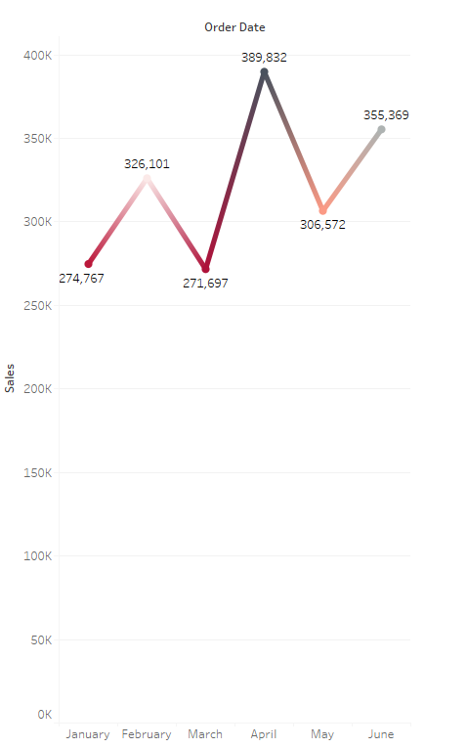

**Visualizations:**

1. **Sales** **Trend:**

This line chart shows the sales trend over time, highlighting significant sales peaks and troughs.

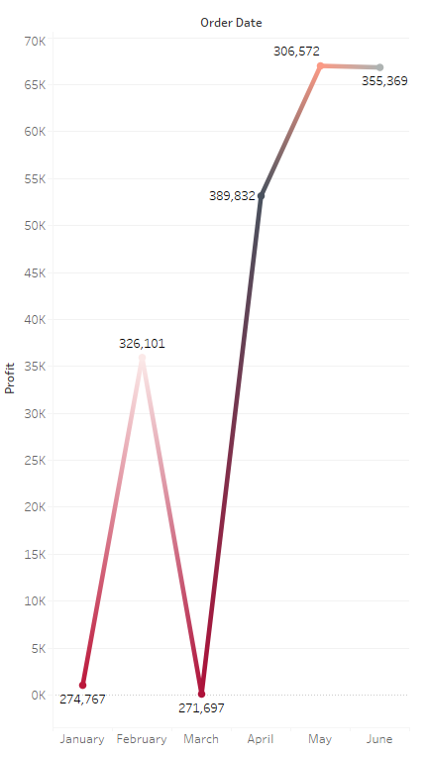

1. **Profit Trend:**

It displays the profit trend over time, indicating periods of high and low profitability.

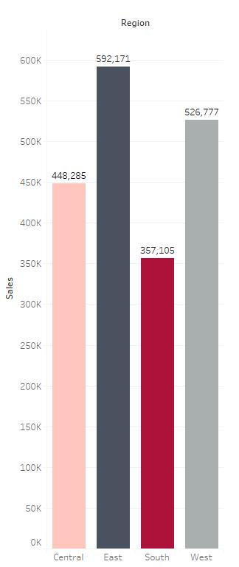

1. **Sales by Region:**

This chart illustrates the sales distribution across different regions.

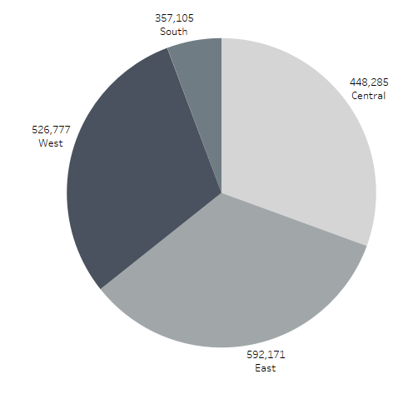

1. **Profit by Region:**

It presents the profit distribution across different regions.

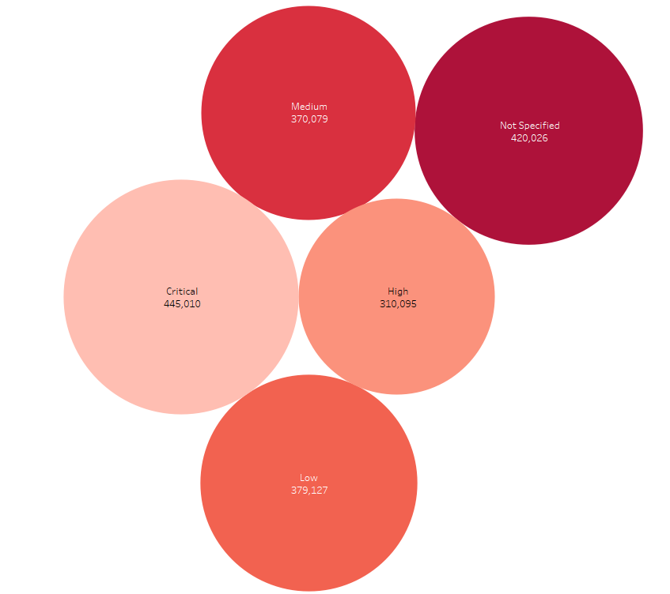

1. **Sales by Order Priority:**

This shows the sales based on order priority.

1. **Order Priority Distribution:**

This pie chart illustrates the distribution of orders by priority.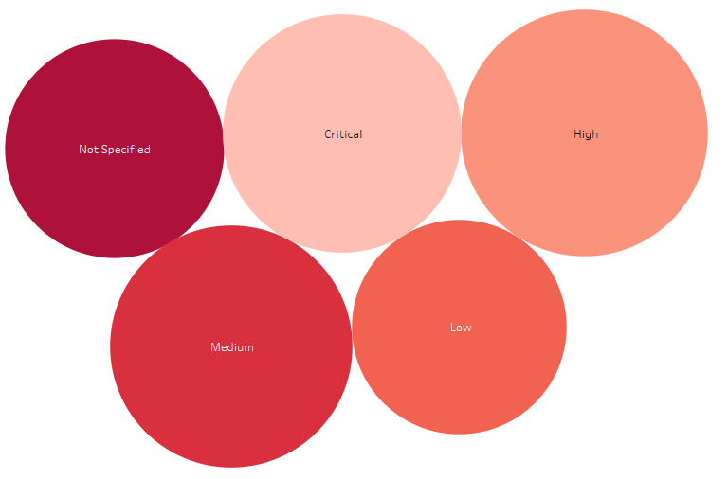

**Insights:**



1. **Sales Trend:**

We can see that April 2015 had the highest sales with a total of $389,832, followed by June and February.

1. **Profit Trend:**

May had the highest profit of $306,572, followed closely by June and April.

1. **Sales by Region:**

The East region had the highest sales with a total of $592,171, followed by the West and Central regions.

1. **Profit by Region:**

The highest profit was seen in the East region, with a total of $592,171.

1. **Sales by Order Priority:**

Critical order priority had the highest sales, amounting to $445,010.

1. **Order Priority Distribution:**

High order priority had the highest distribution among all order priorities.

**Conclusion:**

**Sales Performance:**

The sales trends indicate that April 2015 was a particularly strong month for the company, achieving the highest sales of $389,832. This peak, along with other significant sales periods in June and February, highlights the potential for seasonality or specific events driving sales increases.

The consistent growth in sales over the years demonstrates a positive trajectory and the effectiveness of the company's sales strategies.

**Profit Trends:** 

Profit analysis reveals that May had the highest profit of $306,572, followed closely by June and April. This alignment with the sales trends suggests that high sales months also translate into high profitability.

The overall profit trend mirrors the sales trend, indicating that the company's cost management practices are effectively supporting profitability during high sales periods.

**Regional Analysis:**

The East region stands out as the top-performing region in terms of both sales and profit, with total sales of $592,171 and an equivalent profit figure. This indicates a strong market presence and effective strategies in this region.

The performance of the West and Central regions also contributes significantly to the overall sales and profit, suggesting a well-distributed regional strategy.

**Order Priority Impact:**

Critical order priority drives the highest sales, amounting to $445,010. This underscores the importance of prioritizing critical orders to maximize sales.

The distribution of orders by priority shows that high-priority orders are most prevalent, which aligns with the high sales and profit figures. This indicates a focus on customer satisfaction and expedited shipping.

**Strategic Implications:**

The analysis highlights the importance of focusing on high-priority and critical orders to drive sales and profitability.

The strong performance in the East region suggests that strategies implemented in this region could be replicated in other regions to boost overall performance.

The consistent sales and profit growth over the years indicates a successful business strategy, providing a solid foundation for future growth and expansion.



Overall, the Sales and Profit Analysis Dashboard offers valuable insights into the company's performance, guiding strategic decisions to sustain and enhance growth and profitability.